Penetration Testing Lab Report - Day 10
Title: Automated vs Manual Vulnerability Assessment
Name: Urooj
Date: 13 May 2026
Target IP: 192.168.56.102
Attacker IP: 192.168.56.101

1. OBJECTIVE:
The objective of this lab was to perform automated vulnerability scanning using Nmap and then manually validate the findings using standard Linux tools (nc, curl, smbclient) to understand the difference between automated and manual assessment.

2. LAB ENVIRONMENT:
- Attacker Machine: Kali Linux (192.168.56.101)
- Target Machine: Metasploitable 2 (192.168.56.102)
- Network Mode: Host-Only Adapter (VirtualBox)
- Tools Used: nmap, ping, ip, nc, curl, smbclient

3. METHODOLOGY AND RESULTS:

Step 1: IP Configuration Check
Command Used: ip a
Result: Kali Linux IP is 192.168.56.101 and loopback is active. Network interface is up.
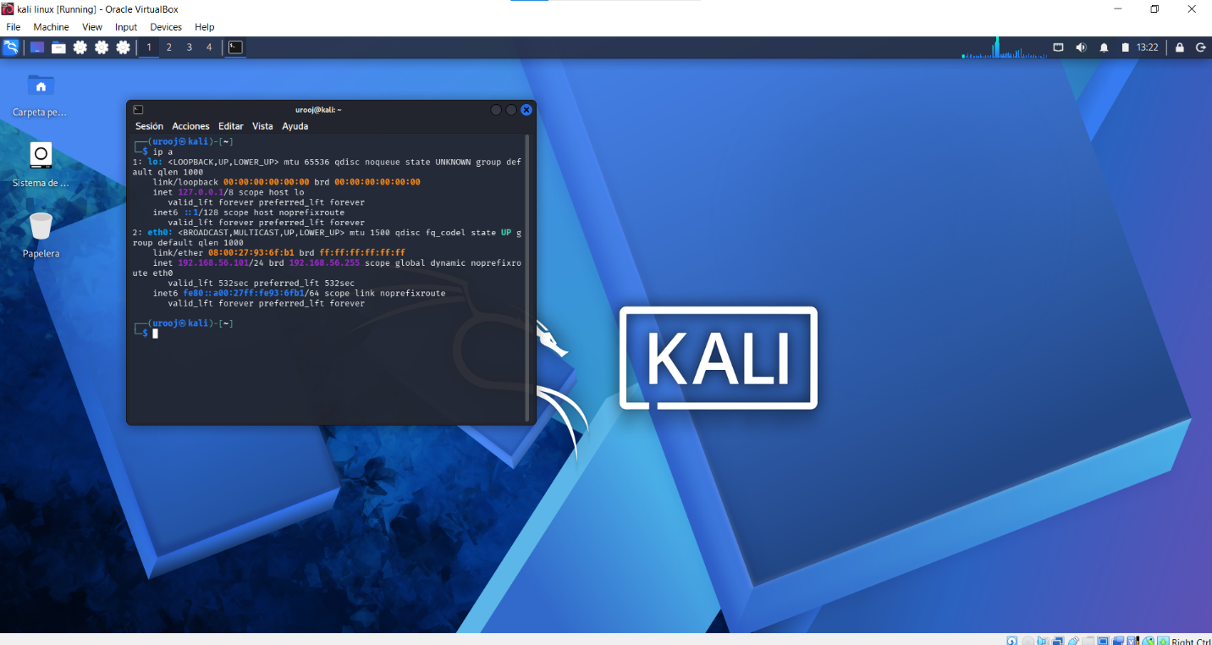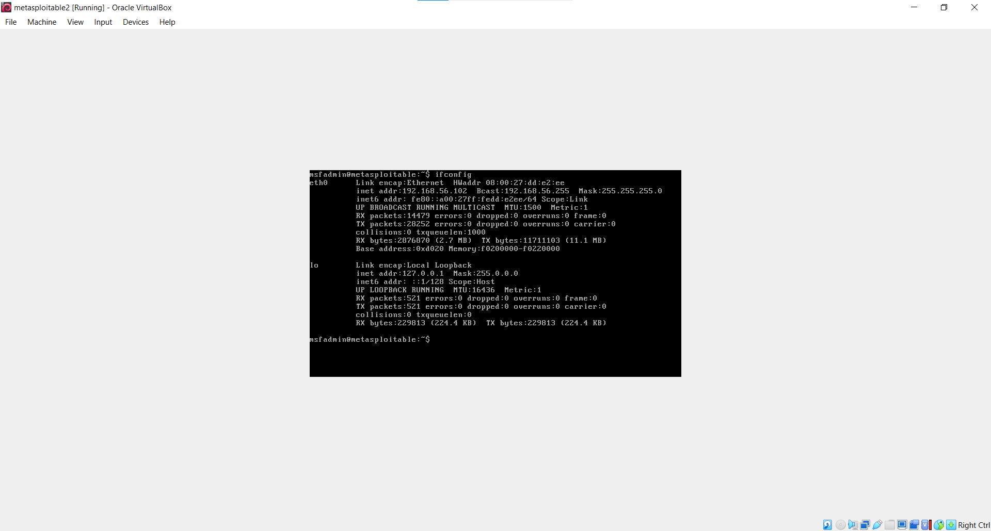

Step 2: Connectivity Check
Command Used: ping 192.168.56.102 -c 12
Result: 12 packets transmitted, 12 received, 0% packet loss. Target is reachable.

Step 3: Automated Vulnerability Scanning
Command Used: nmap -sV -sC -oN nmap_scan.txt 192.168.56.102
Result: Scan completed in 23.18 seconds. Found 23 open TCP ports.
Critical findings:
- 23/tcp open telnet (clear-text, high risk)
- 80/tcp open http Apache/2.2.8 (Ubuntu) DAV/2
- 445/tcp open microsoft-ds Samba 3.0.20-Debian
- 21/ftp vsftpd 2.3.4, 22/ssh OpenSSH 4.7p1, 3306/mysql, 5432/postgresql
- Message signing disabled (dangerous, defaults to off)
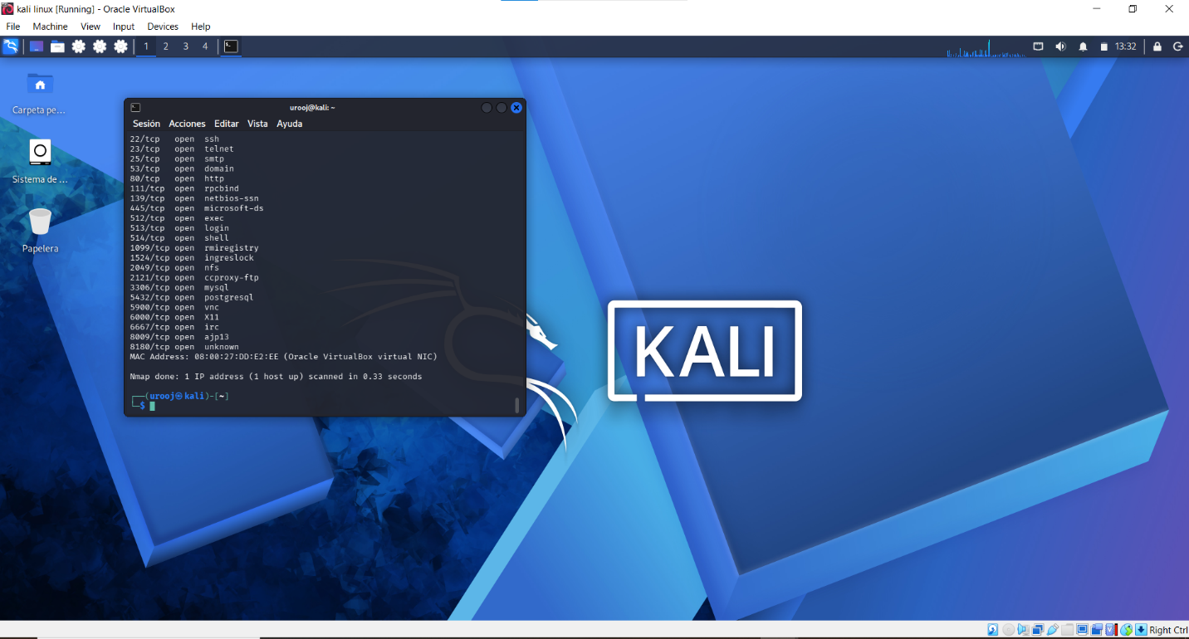
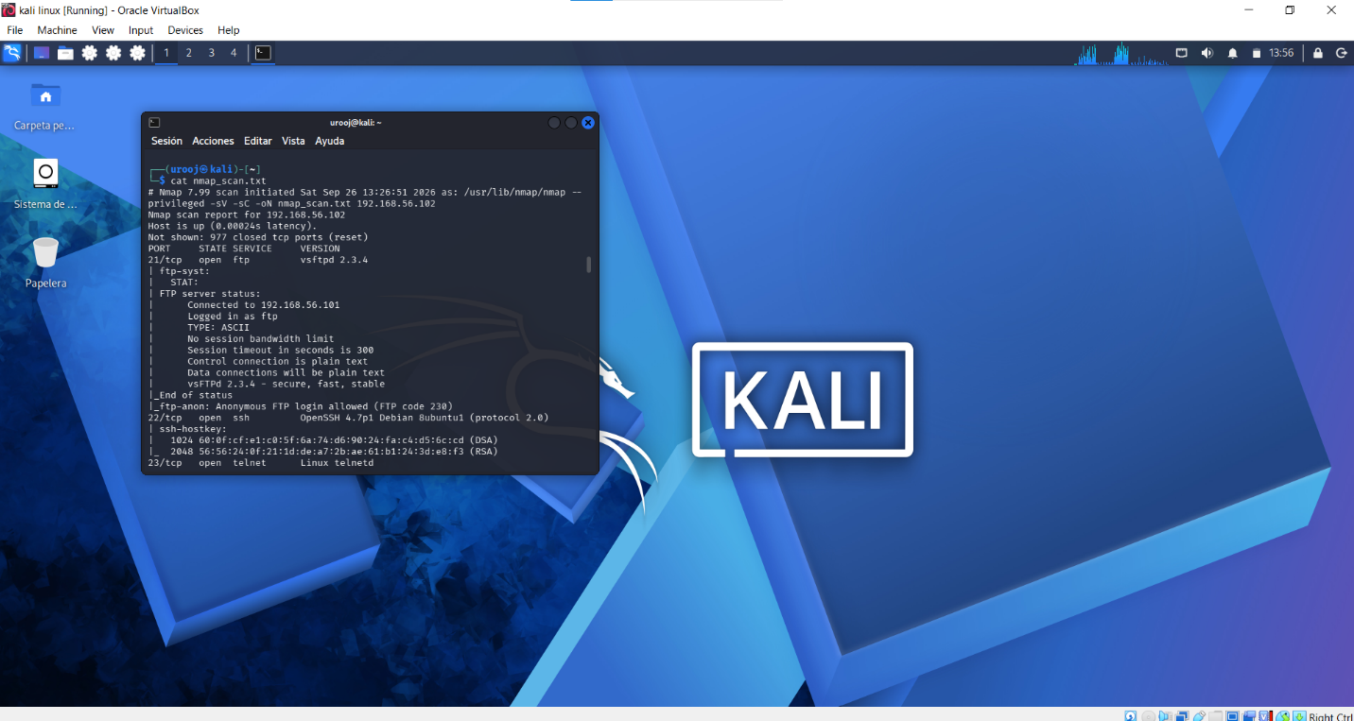

Step 4: Manual Validation

a) Manual Validation for Port 23 (Telnet):
Command Used: nc 192.168.56.102 23
Result: Connection established successfully. Garbled banner received which confirms Telnet service is listening. This validates automated finding and proves it is a true positive. Risk is HIGH.
[-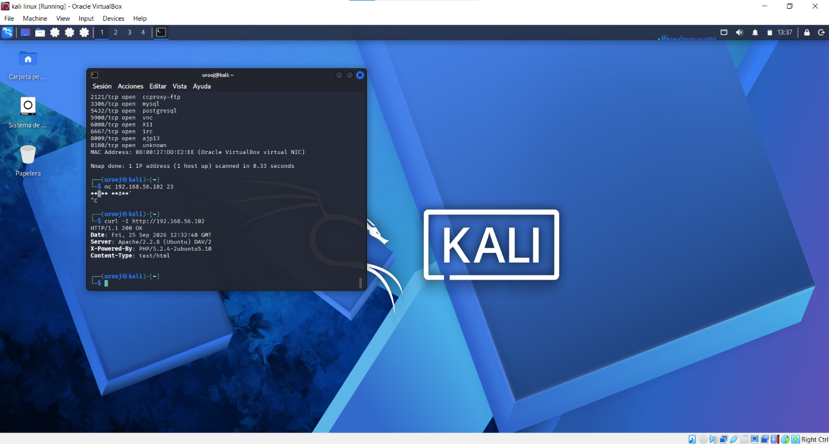 nc 192.168.56.102 23 result]

b) Manual Validation for Port 80 (HTTP):
Command Used: curl -I http://192.168.56.102
Result: HTTP/1.1 200 OK
Server: Apache/2.2.8 (Ubuntu) DAV/2
X-Powered-By: PHP/5.2.4-2ubuntu5.10
This confirms an outdated web server from 2008. High Risk due to known CVEs in Apache 2.2.8 and PHP 5.2.4.
[- curl -I result]

c) Manual Validation for Port 445 (SMB):
Command Used: smbclient -L //192.168.56.102 -N
Result: Anonymous login successful
Sharename Type: print$, tmp, opt, IPC$, ADMIN$
Workgroup: WORKGROUP, Master: METASPLOITABLE
This confirms Critical vulnerability - SMB allows anonymous access without password.
[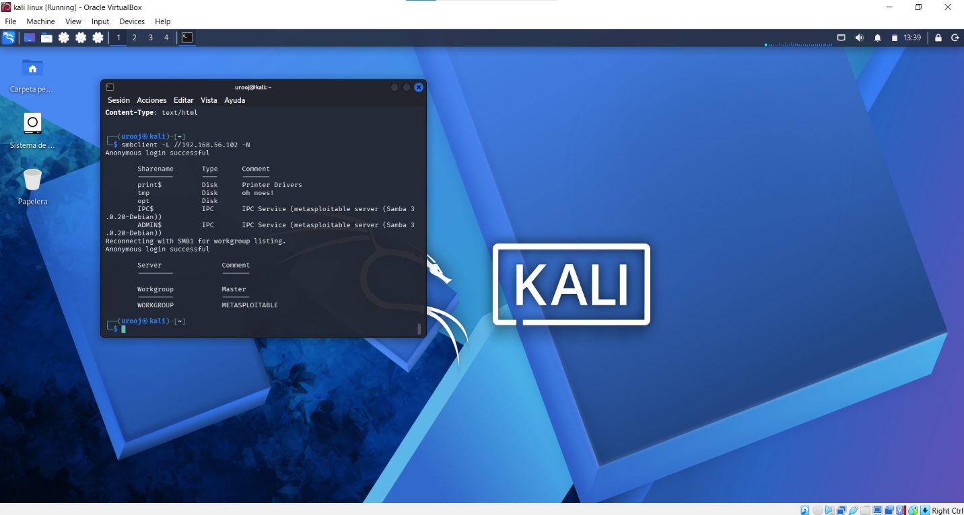- smbclient -L result]

4. COMPARISON TABLE:

| Port | Automated Finding (Nmap) | Manual Command | Manual Result | Status | Risk |
| :--- | :--- | :--- | :--- | :--- | :--- |
| 23/tcp | open telnet | nc 192.168.56.102 23 | Connected | Confirmed | High |
| 80/tcp | Apache 2.2.8 | curl -I http://192.168.56.102 | Apache 2.2.8 / PHP 5.2.4 | Confirmed | High |
| 445/tcp | Samba 3.0.20 | smbclient -L //192.168.56.102 -N | Anonymous login successful | Confirmed | Critical |

5. CONCLUSION:
The automated scanner (Nmap) quickly identified 23 open ports and service versions. Manual validation using nc, curl, and smbclient confirmed that these findings are true positives and not false positives. The manual checks revealed critical misconfigurations like anonymous SMB login, clear-text Telnet, and a highly outdated Apache server. This lab proves that in real penetration testing, automated scanning provides initial visibility, but manual validation is essential for accurate risk assessment.

END OF REPORT

